Pizza Store Data Analysis

1. Total Revenue

select sum(total_price) as total_revenue from pizza_sales;

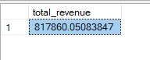

1. Average order Value

select sum(total_price) / count(distinct order_id) as average_order_value

from pizza_sales;



1. Total Pizzas Sold (add column name)

select sum(quantity)

from pizza_sales;



1. Total Orders

select count(distinct order_id) as total_orders

from pizza_sales;



1. Average Pizzas per order

select cast(cast(sum(quantity) as decimal(10,2)) / cast(count(distinct order_id) as decimal(10,2)) as decimal(10,2)) as avg_pizza_per_order

from pizza_sales;



1. Daily Trend for total orders

select datename(DW, order_date) as order_day, count(distinct order_id) as total_orders

from pizza_sales

group by datename(DW, order_date);

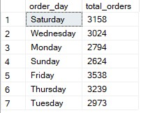

1. Monthly trend for total orders

select datename(month, order_date) as month_name, count(distinct order_id) as total_orders

from pizza_sales

group by datename(month, order_date)

order by total_orders desc;

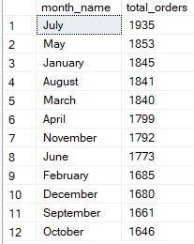

1. Percentage of sales by pizza category

select pizza_category, sum(total_price) * 100 / (select sum(total_price) from pizza_sales) as pct_of_sales

from pizza_sales

group by pizza_category;

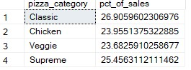

1. Percentage of sales by pizza size

select pizza_size, sum(total_price) * 100 / (select sum(total_price) from pizza_sales) as pct_of_sales

from pizza_sales

group by pizza_size

order by pct_of_sales desc;

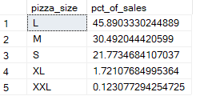

1. Top 5 best sellers by revenue, total quantity and total orders

Top 5 best sellers by revenue-

select top 5 pizza_name, sum(total_price) as revenue

from pizza_sales

group by pizza_name

order by revenue desc;

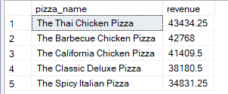

Top 5 best sellers by total quantity-

select top 5 pizza_name, sum(quantity) as total_quantity

from pizza_sales

group by pizza_name

order by total_quantity desc;

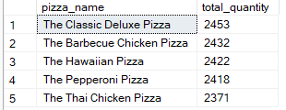

Top 5 best sellers by total orders

select top 5 pizza_name, count(distinct order_id) as total_orders

from pizza_sales

group by pizza_name

order by total_orders desc;

